Task5: Personal Loan Acceptance Prediction (Report)

1. Introduction and Problem Statement:
Banks use direct marketing campaigns to promote products like personal loans, but contacting every customer is costly and inefficient. In this dataset, only 11.7% of customers accepted the loan offer, meaning nearly 9 out of 10 calls produced no result.
The objective of this project is to predict whether a customer will accept a personal loan offer using their demographic, financial, and campaign-related information. This allows the bank to focus resources on high-probability customers, reduce wasted outreach, and improve overall campaign performance.

2. Dataset Understanding and Description:
The dataset comes from the UCI Machine Learning Repository and is based on direct phone marketing campaigns by a Portuguese bank.
- Total records: 45,211 rows and 17 columns
- Target variable: y — whether the customer subscribed (yes or no)
- Class split: 88.3% said no, 11.7% said yes
The features fall into three groups. The first group covers customer demographics — age, job type, marital status, and education level. The second group covers financial profile — account balance, whether the customer has a housing loan, personal loan, or credit default. The third group covers campaign details — contact type, call duration, number of contacts made, and the outcome of any previous campaign.

3. Data Cleaning and Preparation:
The dataset was clean with no missing values and no duplicate records. The following preparation steps were applied.
Binary columns like default, housing, loan, and the target variable y were converted from yes/no strings to 0 and 1. Categorical columns such as job, marital, education, contact, month, and poutcome were one-hot encoded, expanding the feature set from 16 to 42 columns. For Logistic Regression, all features were standardised using StandardScaler. The data was split into 80% for training (36,168 records) and 20% for testing (9,043 records), using stratified splitting to maintain the class balance in both sets.
4. Exploratory Data Analysis (EDA):

Target Distribution: The dataset is imbalanced — only 11.7% of customers accepted the offer. This means accuracy alone is not a reliable evaluation metric, so F1 score and ROC-AUC were prioritised.

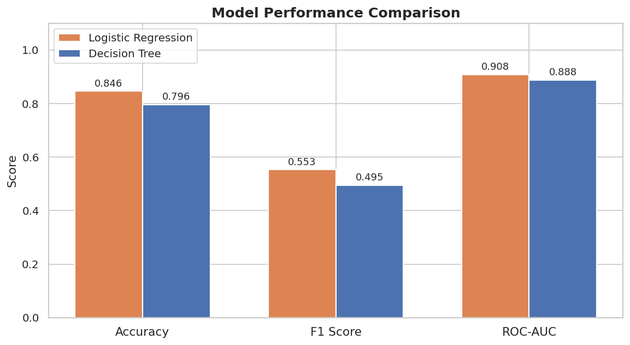
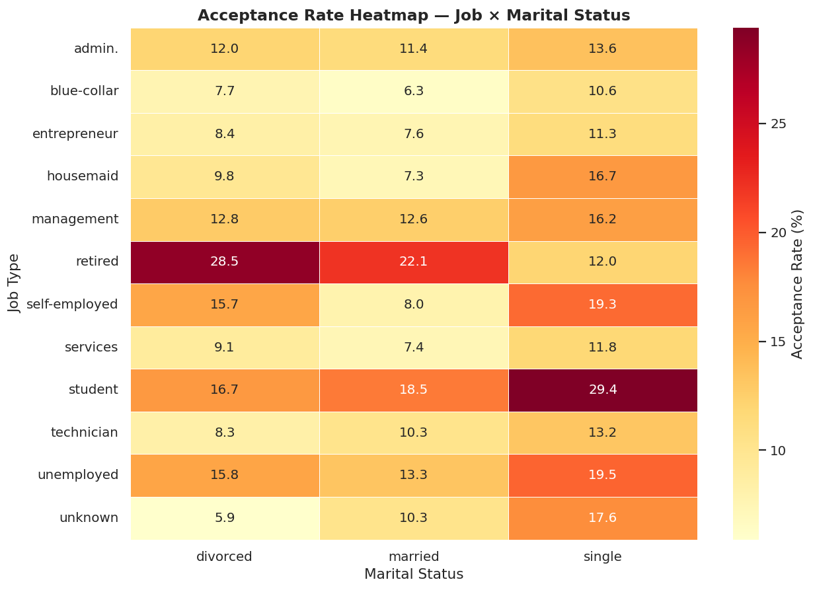

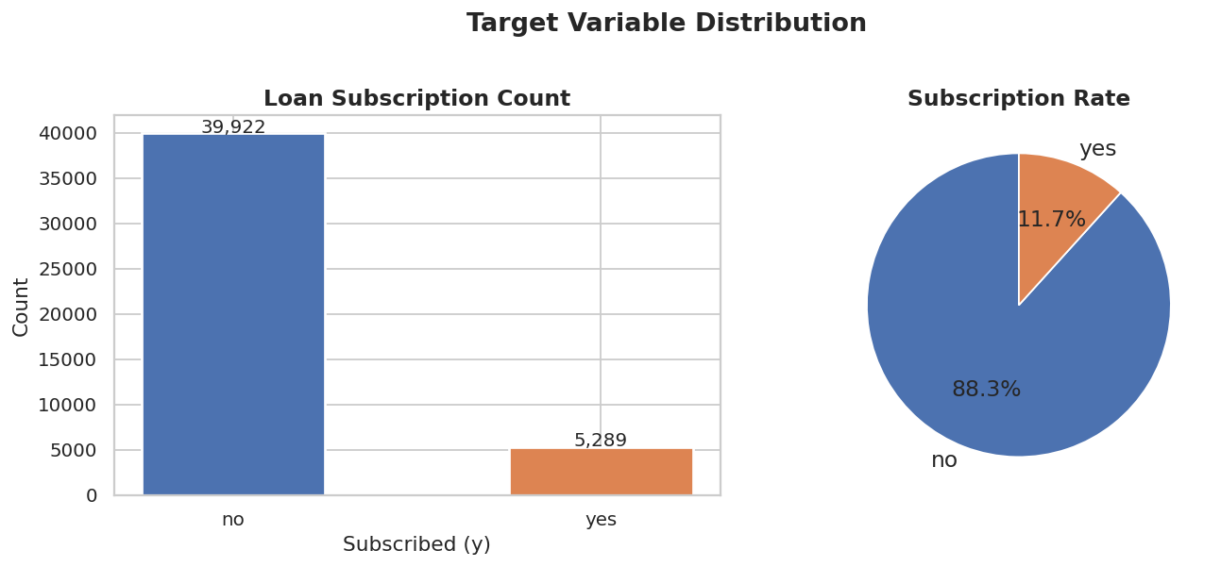
Age: Customer ages range from 18 to 95, with a mean of 41 years. Acceptance rates follow a U-shaped pattern — younger customers (18–25) and older customers (65+) accept at higher rates, while middle-aged customers (36–45) are the least responsive.
Job Type: Students have the highest acceptance rate at 28.7%, followed by retired customers at 22.8%. Blue-collar workers have the lowest rate at 7.3%. Job type is one of the clearest demographic separators in the data.
Marital Status: Single customers accept at 14.95%, compared to 11.95% for divorced and 10.12% for married customers.
Education: Acceptance rates increase with education level — primary educated customers accept at 8.6%, while tertiary educated customers accept at 15.0%.
Balance and Call Duration: Customers who accepted had a higher average balance (€1,804 vs €1,303) and much longer call durations (537 seconds vs 221 seconds). Call duration turned out to be the strongest predictor in the entire dataset.
Previous Campaign Outcome: Customers who had a successful prior campaign interaction converted at approximately 64.7% — by far the highest of any group and a critical lead qualifier.

5. Model Training and Testing:
Two classification models were trained and compared.
Logistic Regression was used as the primary model. It is interpretable, reliable, and well-suited for binary classification. A pipeline was built combining StandardScaler and the classifier, with class_weight set to balanced to handle the imbalanced target.
Decision Tree Classifier was used as the second model with a max depth of 6 to prevent overfitting, also with balanced class weighting.
Both models were validated using 5-fold stratified cross-validation before final evaluation on the test set.
Two classification models were trained and compared.
Logistic Regression was used as the primary model. It is interpretable, reliable, and well-suited for binary classification. A pipeline was built combining StandardScaler and the classifier, with class_weight set to balanced to handle the imbalanced target.
Decision Tree Classifier was used as the second model with a max depth of 6 to prevent overfitting, also with balanced class weighting.
Both models were validated using 5-fold stratified cross-validation before final evaluation on the test set.

6. Evaluation Metrics
Metric | Logistic Regression | Decision Tree
Accuracy | 84.60% | 79.56%
Precision | 41.86% | 34.82%
Recall | 81.38% | 85.63%
F1 Score | 0.5528 | 0.4951
ROC-AUC | 0.9079 | 0.8883
MAE | 0.1540 | 0.2044
RMSE | 0.3925 | 0.4521
CV ROC-AUC | 0.9097 ± 0.005 | 0.8862 ± 0.005
Confusion Matrix — Logistic Regression: Out of 9,043 test records, the model correctly identified 861 true loan acceptors, missed 197, flagged 1,196 non-acceptors incorrectly, and correctly excluded 6,789.
Confusion Matrix — Decision Tree: The tree caught slightly more acceptors (906) but also produced more false positives (1,696), resulting in lower precision.
Logistic Regression is the better overall model — higher ROC-AUC, better F1 score, fewer false positives, and stable cross-validation performance.

7. Conclusion:
The Logistic Regression model achieved a ROC-AUC of 0.91, successfully identifying 81% of actual loan acceptors. Below are the key takeaways from the analysis.
Call duration matters most. Customers who accepted the offer had calls lasting more than twice as long as those who declined. Longer conversations reflect genuine interest and are the strongest single predictor of acceptance.
Students and retired customers are the best targets. These two groups converted at 28.7% and 22.8% respectively — significantly above the 11.7% average. Campaigns directed at these segments will yield the highest return.
Single and tertiary-educated customers are more receptive. Single customers convert at a 48% higher relative rate than married customers. Tertiary-educated customers convert at nearly twice the rate of those with primary education.
Prior campaign success is the most reliable lead qualifier. Customers who had a positive outcome in a previous campaign converted at around 65% in the current one. Re-engaging this group should be the first priority of any campaign.
Fewer contacts are better. Customers who accepted were contacted an average of 2.14 times, while those who declined were contacted 2.85 times. Repeated follow-ups beyond 3 attempts are unlikely to add value.
Higher balance customers are more likely to accept. Accepted customers had an average balance of €1,804 compared to €1,303 for non-acceptors. Pre-filtering leads by account balance above the median can enrich the quality of the outreach list.
In summary, the model provides a practical and interpretable tool for targeting the right customers. Combined with the segment insights above, the bank can significantly improve campaign efficiency without increasing budget.

